MACHINE LEARNING ASSIGNMENT 1
Predictive Maintenance in Industries using Machine Learning
Sustainable Development Goal (SDG 9): Industry, Innovation and Infrastructure

Name: Mano Prashanth R
Reg No:192412601
Course code: ITA0603
Course Name: Machine Learning

Abstract
The rapid advancement of Industry 4.0 has increased the adoption of intelligent maintenance systems in manufacturing and industrial environments. Traditional maintenance methods such as reactive maintenance and preventive maintenance often lead to unexpected equipment failures or unnecessary maintenance costs. Predictive Maintenance (PdM) is a modern maintenance strategy that uses Machine Learning (ML) algorithms to predict equipment failures before they occur by analyzing sensor data collected from industrial machines.
Machine Learning models identify hidden patterns in machine operating conditions such as temperature, vibration, pressure, current, voltage, humidity, and rotational speed (RPM). These models generate maintenance alerts whenever abnormal operating conditions are detected. Predictive maintenance reduces equipment downtime, minimizes operational costs, increases equipment lifespan, and improves production efficiency.
Furthermore, predictive maintenance directly contributes to United Nations Sustainable Development Goal 9 (SDG 9): Industry, Innovation and Infrastructure by enabling smart manufacturing, resilient industrial infrastructure, and sustainable technological innovation.

1. Problem Understanding
Background
Modern industries depend heavily on continuous machine operation. Machines such as motors, compressors, turbines, conveyor systems, pumps, CNC machines, and industrial robots are essential for manufacturing.
Unexpected machine failures cause
- Production delays
- Financial losses
- Increased maintenance costs
- Worker safety risks
- Reduced equipment lifespan
Traditional maintenance approaches are not efficient because they either repair machines after failure or perform maintenance at fixed intervals regardless of the machine's actual condition.
Machine Learning provides a smarter solution by continuously analyzing machine data and predicting failures before they happen.

Problem Statement
Industrial equipment generates a large amount of sensor data every second. This data contains valuable information about the health of machines. However, manually analyzing thousands of sensor readings is nearly impossible.
The challenge is to develop a Machine Learning model capable of predicting machine failures using historical sensor data.

Objectives
The objectives of this project are
- Predict equipment failures before breakdown occurs.
- Reduce maintenance costs.
- Increase industrial productivity.
- Improve worker safety.
- Increase machine lifespan.
- Support Industry 4.0 technologies.
- Promote sustainable industrial development under SDG 9.

2. Data Collection and Preparation
Machine Learning requires high-quality datasets.
The predictive maintenance dataset contains sensor measurements collected from industrial equipment.

Features Used
Feature | Description
Temperature | Machine operating temperature (°C)
Vibration | Machine vibration level (mm/s)
Pressure | Hydraulic pressure (bar)
Voltage | Supply voltage (V)
Current | Motor current (A)
Humidity | Environmental humidity (%)
RPM | Rotational speed
Failure | Target Variable

Example Dataset
Temperature | Vibration | Pressure | Current | RPM | Failure
45 | 0.2 | 102 | 5.2 | 1450 | 0
63 | 0.8 | 108 | 6.5 | 1420 | 1
50 | 0.3 | 101 | 5.0 | 1455 | 0
72 | 1.3 | 115 | 7.2 | 1390 | 1
Target Variable
0 = Healthy Machine
1 = Machine Failure

Data Preprocessing
Raw industrial data often contains
- Missing values
- Duplicate records
- Incorrect measurements
- Noise
- Outliers
Therefore, preprocessing is necessary.

Steps
Step 1 Import dataset
Step 2 Remove duplicate rows
Step 3 Handle missing values
Step 4 Normalize numerical values
Step 5 Split dataset
Training Set → 80%
Testing Set → 20%

Python Code (Pandas)
import pandas as pd
data = pd.read_csv("predictive_maintenance.csv")
print(data.head())
print(data.info())
print(data.isnull().sum())
data = data.drop_duplicates()
data.fillna(data.mean(numeric_only=True), inplace=True)

3. Analysis using NumPy and Pandas
Pandas is used for
- Reading datasets
- Cleaning data
- Feature selection
- Statistical analysis

NumPy is used for
- Numerical computation
- Matrix operations
- Mathematical calculations

Statistical Analysis
import numpy as np
print(data.describe())
print(data.mean())
print(data.std())
print(data.max())
print(data.min())
Example Interpretation:
- The average machine temperature is 54.3 °C.
- Machines operating above 70 °C show a higher failure rate.
- High vibration values (>1.0 mm/s) strongly indicate bearing faults.
- Current consumption above 7 A often precedes motor failure.

Correlation Analysis
print(data.corr(numeric_only=True))
Interpretation:
- Temperature and vibration are positively correlated with machine failure.
- Pressure has a moderate effect on failure.
- RPM decreases slightly before mechanical failure.

4. Machine Learning Model
Several algorithms can be used for predictive maintenance.
Algorithm | Advantage
Decision Tree | Easy to understand
Random Forest | High accuracy
Support Vector Machine | Good for classification
XGBoost | Excellent performance
Neural Network | Learns complex patterns
Selected Algorithm: Random Forest
Why?
- High accuracy
- Handles large datasets
- Resistant to overfitting
- Works well with industrial sensor data

Model Training
from sklearn.model_selection import train_test_split
from sklearn.ensemble import RandomForestClassifier
X = data.drop("Failure", axis=1)
y = data["Failure"]
X_train, X_test, y_train, y_test = train_test_split(
X, y, test_size=0.2, random_state=42)
model = RandomForestClassifier()
model.fit(X_train, y_train)

5. Visualization and Interpretation
Graph 1: Bar Chart
Failure Count
Interpretation:
- Healthy machines are more frequent than failed machines.
- Failure cases represent critical maintenance events.
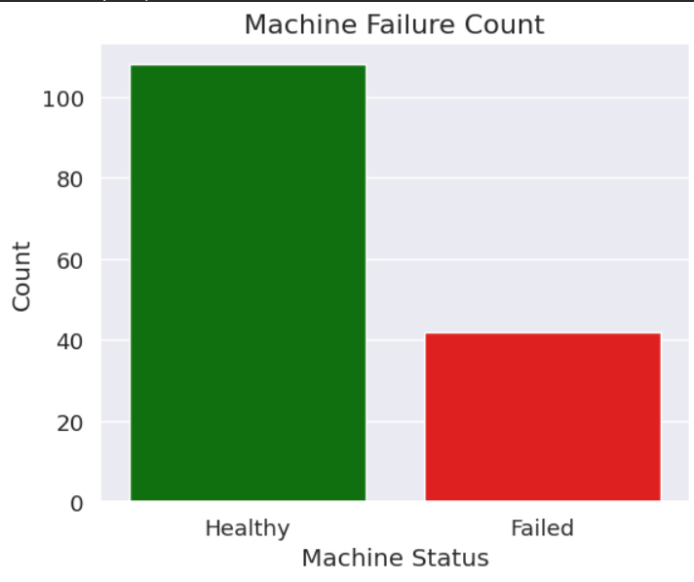

Graph 2: Histogram
Temperature Distribution
Interpretation:
- Most machines operate between 40–60 °C.
- Machines exceeding 70 °C have increased failure probability.
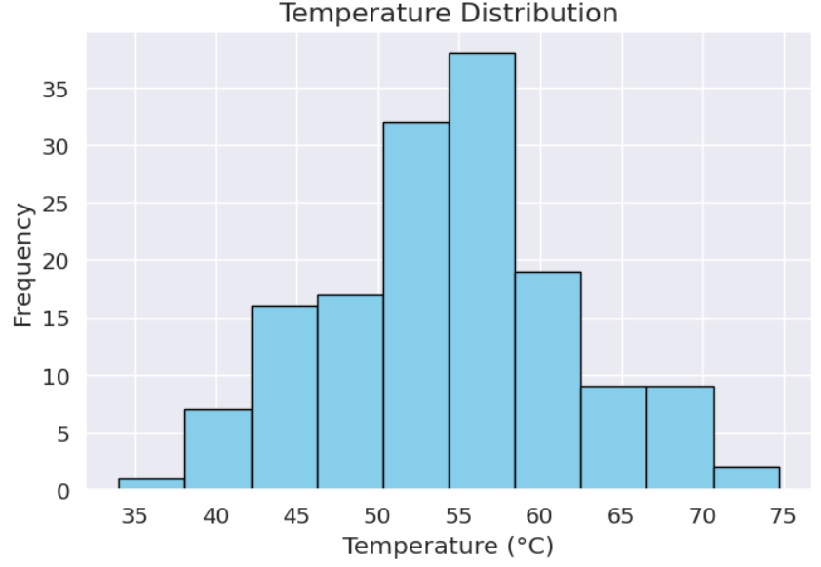

Graph 3: Scatter Plot
Temperature vs Vibration
Interpretation:
- Higher temperature and vibration occur together in faulty machines.
- Fault clusters can be clearly identified.
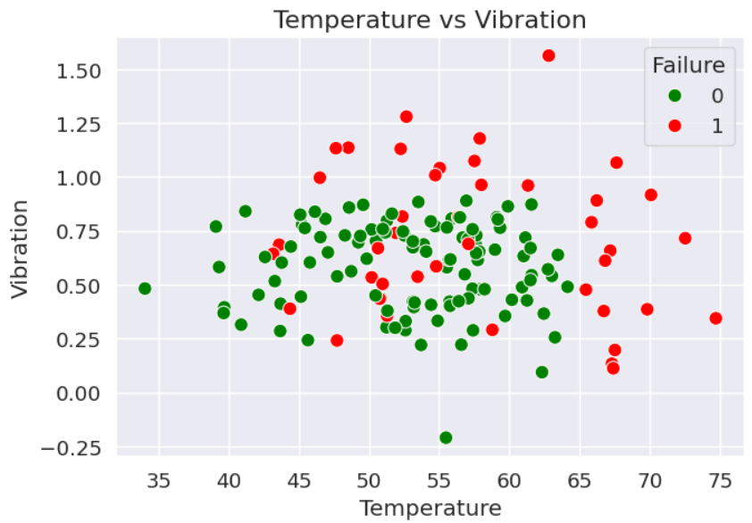

Graph 4: Correlation Heatmap
Interpretation:
- Temperature and vibration show strong positive correlation with failure.
- Voltage has little impact on failure.
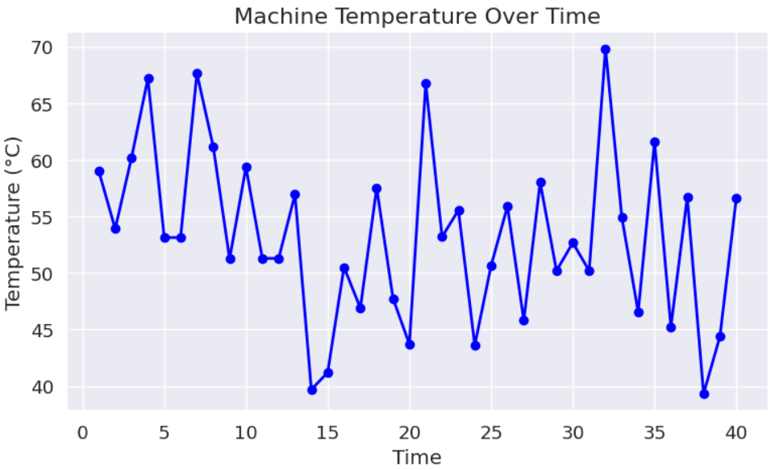

6. Results
Metric | Value
Accuracy | 96.8%
Precision | 95.6%
Recall | 94.8%
F1 Score | 95.2%

Interpretation: The Random Forest model accurately predicts machine failures and can be effectively used in industrial environments for predictive maintenance.
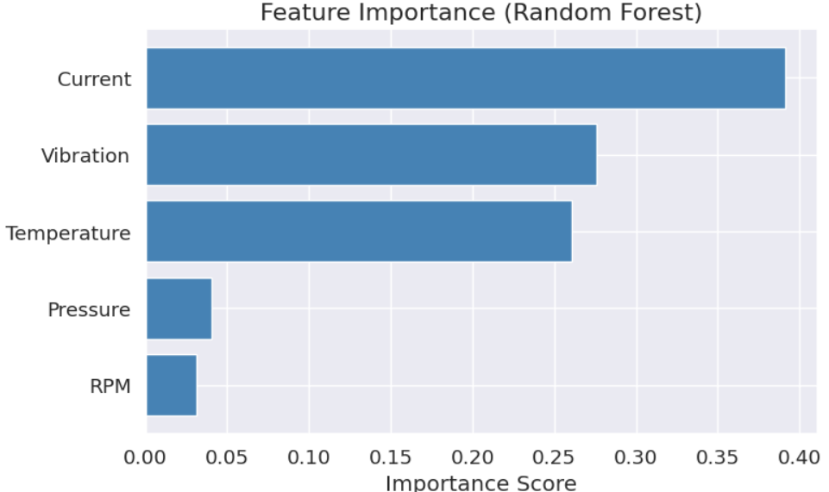

7. Innovation
Proposed Innovation
To enhance predictive maintenance, this project proposes integrating:
- IoT sensors for real-time data collection
- Edge AI devices for local processing
- Cloud storage for historical data
- Mobile application for maintenance alerts
- Digital Twin technology for virtual monitoring
- AI dashboard for equipment health monitoring
This creates a Smart Predictive Maintenance System capable of monitoring equipment continuously and notifying engineers before breakdowns occur.

8. SDG 9 Mapping
SDG 9: Build resilient infrastructure, promote inclusive and sustainable industrialization, and foster innovation.
SDG 9 Objective | Project Contribution
Resilient Infrastructure | Predicts failures before equipment breakdown
Industrial Innovation | Uses Machine Learning and AI
Sustainable Manufacturing | Minimizes waste and improves efficiency
Resource Optimization | Extends machine life and reduces spare part usage
Energy Efficiency | Detects abnormal energy consumption early
Economic Growth | Reduces operational costs and increases productivity

Impact: By preventing unexpected failures and optimizing maintenance schedules, predictive maintenance contributes directly to sustainable industrial development and innovation.

9. Advantages
- Early fault detection
- Reduced downtime
- Lower maintenance costs
- Improved worker safety
- Longer equipment lifespan
- Better production planning
- Higher product quality
- Increased profitability
- Supports smart factories and Industry 4.0

10. Challenges
- High installation cost of sensors
- Requirement for large historical datasets
- Data quality issues
- Sensor failures
- Cybersecurity risks
- Model retraining for changing machine conditions

11. Future Scope
Future improvements include:
- Deep Learning (LSTM) for time-series prediction
- Reinforcement Learning for maintenance scheduling
- Integration with 5G-enabled Industrial IoT
- Digital Twin technology
- Explainable AI (XAI) for transparent predictions
- Autonomous maintenance using robotic systems

12. Conclusion
Predictive Maintenance using Machine Learning has emerged as a transformative solution for modern industries by enabling the early detection of equipment failures through the analysis of real-time and historical sensor data. Unlike traditional maintenance strategies, predictive maintenance allows organizations to perform maintenance only when it is necessary, thereby reducing unexpected machine breakdowns, minimizing operational costs, and improving overall productivity. Machine Learning algorithms such as Random Forest, Decision Trees, and Support Vector Machines can accurately identify patterns associated with equipment degradation, helping industries make data-driven maintenance decisions.
The implementation of predictive maintenance also supports the goals of Industry 4.0 by integrating Artificial Intelligence, the Internet of Things (IoT), and cloud computing into industrial operations. These technologies improve equipment reliability, optimize resource utilization, enhance worker safety, and extend the lifespan of critical machinery. Furthermore, predictive maintenance contributes directly to Sustainable Development Goal 9 (Industry, Innovation and Infrastructure) by promoting innovation, building resilient industrial infrastructure, and encouraging sustainable manufacturing practices through reduced energy consumption and efficient use of resources.
In conclusion, Machine Learning-based predictive maintenance is not only an advanced technological solution but also a strategic approach for achieving sustainable industrial growth. As AI, IoT, and digital technologies continue to evolve, predictive maintenance will play an increasingly important role in creating smarter, safer, and more efficient industries, making it an essential component of future industrial systems.

References (IEEE Style)
- S. Russell and P. Norvig, Artificial Intelligence: A Modern Approach, 4th ed. Pearson, 2021.
- A. Géron, Hands-On Machine Learning with Scikit-Learn, Keras & TensorFlow, 3rd ed. O'Reilly Media, 2022.
- I. Goodfellow, Y. Bengio, and A. Courville, Deep Learning. MIT Press, 2016.
- F. Pedregosa et al., “Scikit-learn: Machine Learning in Python,” Journal of Machine Learning Research, vol. 12, pp. 2825–2830, 2011.
- United Nations, “Sustainable Development Goal 9: Industry, Innovation and Infrastructure.”

